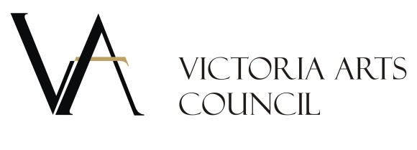

For Immediate Release
November 20, 2017

LITTLE GEMS Holiday Art & Craft Fair Decks the Walls!

The countdown to the holidays begins. You can get a jump-start on holiday shopping at the LITTLE GEMS Holiday Arts & Craft Fair at the Victoria Arts Council (VAC) located at The Bay Centre (636 Fort Street).

Opening Thursday, November 23 until December 20, the walls will be decked out with hundreds of original art works, sculptures, fabric and glass creations, greeting cards and prints by local artists and artisans. If you haven’t yet visited Victoria Arts Council’s Art Space – this is your chance!
All works are under $300 with proceeds shared 20/80 between the VAC and the artist. Funds raised through the Little Gems Show allow us to make cultural programming and art education accessible to our community. See something you like, buy it, and we’ll take it off the wall and wrap it up for you to take home, or to gift the experience of art!
“The continued and generous support of The Bay Centre is much appreciated, and has been a critical factor in the success all VAC art exhibitions including Little Gems. This dynamic venue offers the opportunity to make local art easily accessible to our community.” Says VAC Executive Director, Stephanie Eisenbraun.

The Victoria Arts Council is a non-profit society and member-based organization dedicated to advancing local arts and culture. VAC partners with arts, culture, community organizations and businesses, to deliver programs for all art disciplines.

- 30-

IMPORTANT INFORMATION

Location: Victoria Arts Council 636 Fort Street, located in The Bay Centre

Opening Reception: Thursday, November 23 from 6:30-8:30pm

Fair Dates: Thursday, November 23 – Wednesday, December 20, 2017

Hours:
Saturday – Wednesday 11 am -6pm
Thursday/Friday 11am – 7pm

Contact:
Stephanie Eisenbraun
Executive Director
Victoria Arts Council
778-533-7123
vicartscouncil.ca

